Project Title
Full Stack E-Commerce Web Application

1. Project Overview
This project is a Full Stack E-Commerce Web Application developed using React.js, Node.js, Express.js, and MongoDB. The application provides an end-to-end online shopping experience including user authentication, product browsing, cart management, It demonstrates real-world implementation of scalable MERN stack architecture.

2. Objectives of the Project
- To design and develop a real-world e-commerce platform
- To implement secure user authentication and authorization
- To manage products, carts, orders, and users efficiently
- To integrate payment gateways for online transactions
- To apply industry-level project structure and best practices

3. Technology Stack

Frontend
- React.js
- React Router DOM
- Context API (Auth & Cart Management)
- Fetch API
- CSS

Backend
- Node.js
- Express.js
- RESTful APIs

Database
- MongoDB (NoSQL)
- Mongoose

4. Project Architecture
The project follows a Client–Server Architecture:
- Frontend (React) handles UI and user interactions
- Backend (Node + Express) handles APIs and business logic
- MongoDB stores application data (users, products, orders)

5. Functional Modules

5.1 User Module (Customer)
- User Registration & Login
- Email verification & password reset
- Profile management
- Wishlist management
- Cart management

5.2 Product Module
- Product listing with pagination
- Product details with images and pricing
- Search, filter, and sort functionality

5.3 Order & Checkout Module
- Address selection
- Payment methods (COD / Online Gateway)
- Order confirmation & tracking
- Invoice generation (PDF)

5.4 Admin Module
- Admin authentication
- Dashboard analytics
- Product management
- Order status management
- User management

6. Core Features
- Secure user authentication
- Product browsing with search & filters
- Cart & wishlist functionality
- Online and offline payment support
- Admin dashboard for full control

7. Project Directory Structure

Backend Structure
ecommerce-app/
├── backend/
│ ├── src/
│ │ ├── config/
│ │ ├── models/
│ │ ├── controllers/
│ │ ├── routes/
│ │ ├── middlewares/
│ │ ├── utils/
│ │ ├── app.js
│ │ └── server.js
│ ├── package.json
│ └── .env

Frontend Structure
frontend/
├── src/
│ ├── assets/
│ ├── components/
│ ├── pages/
│ ├── context/
│ ├── hooks/
│ ├── services/
│ ├── utils/
│ ├── App.jsx
│ ├── main.jsx
│ └── index.css
├── package.json
└── .env

8. User Interface Description

Home Page
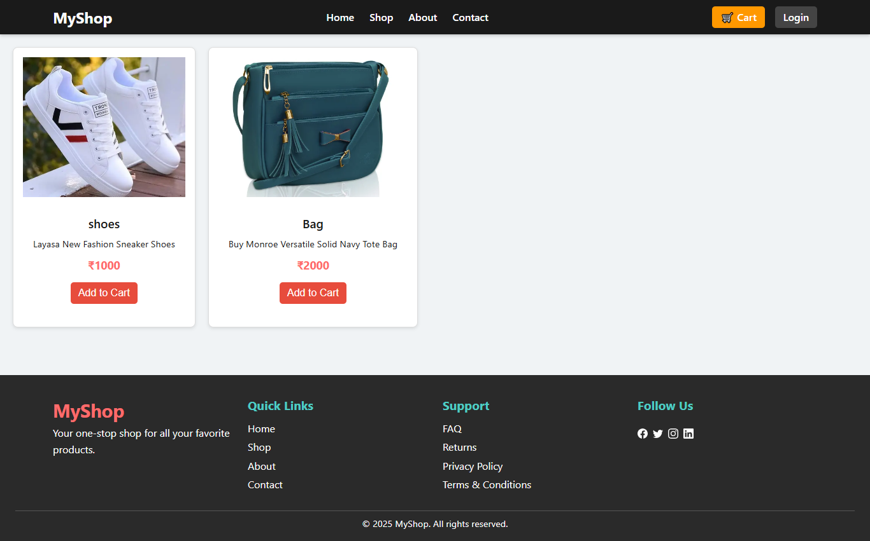
- Product listings with categories and filters

Register Page

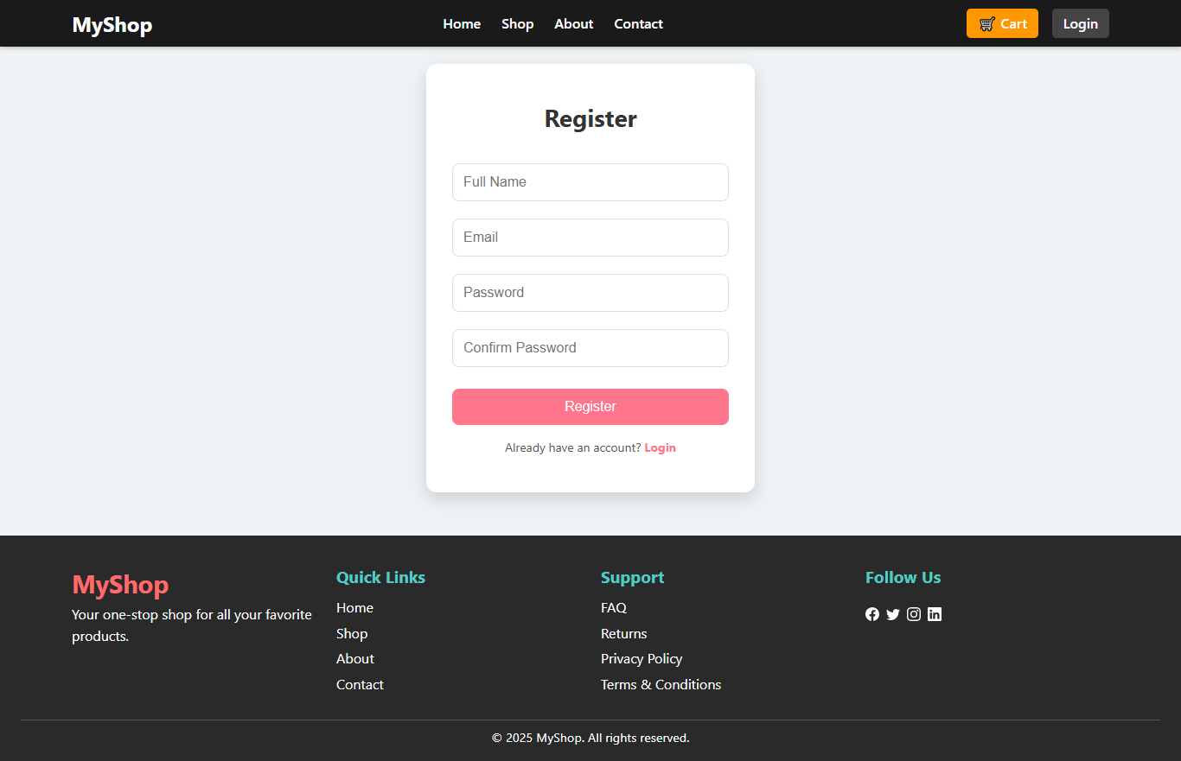

Product Detail Page
- Product images, price, stock, and description

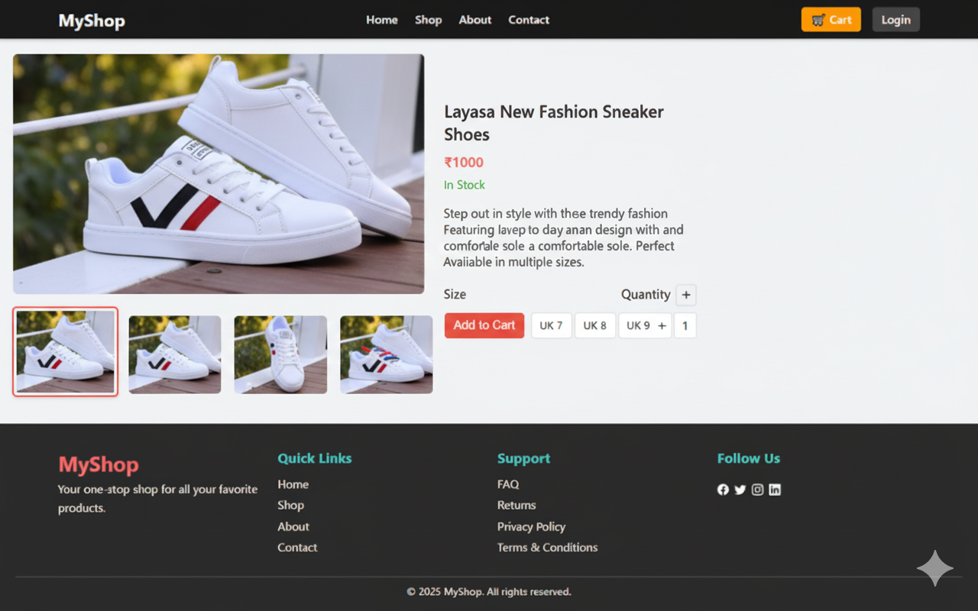

Cart Page
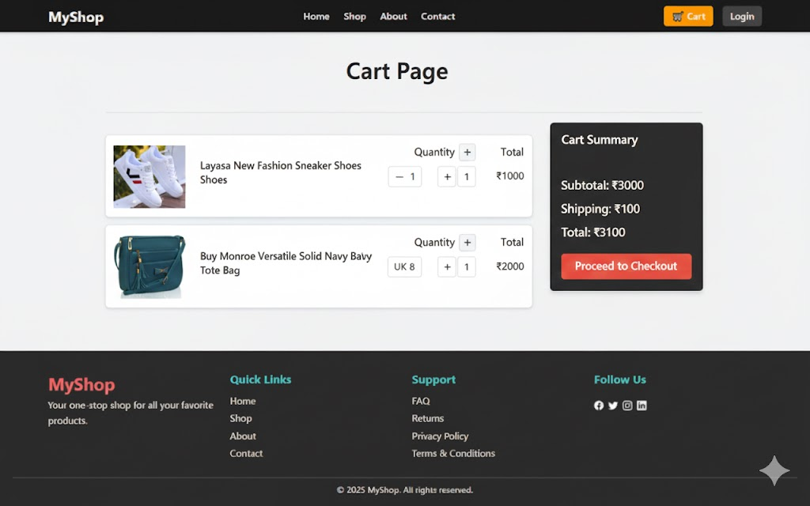
- Added products with quantity update option

Admin Dashboard
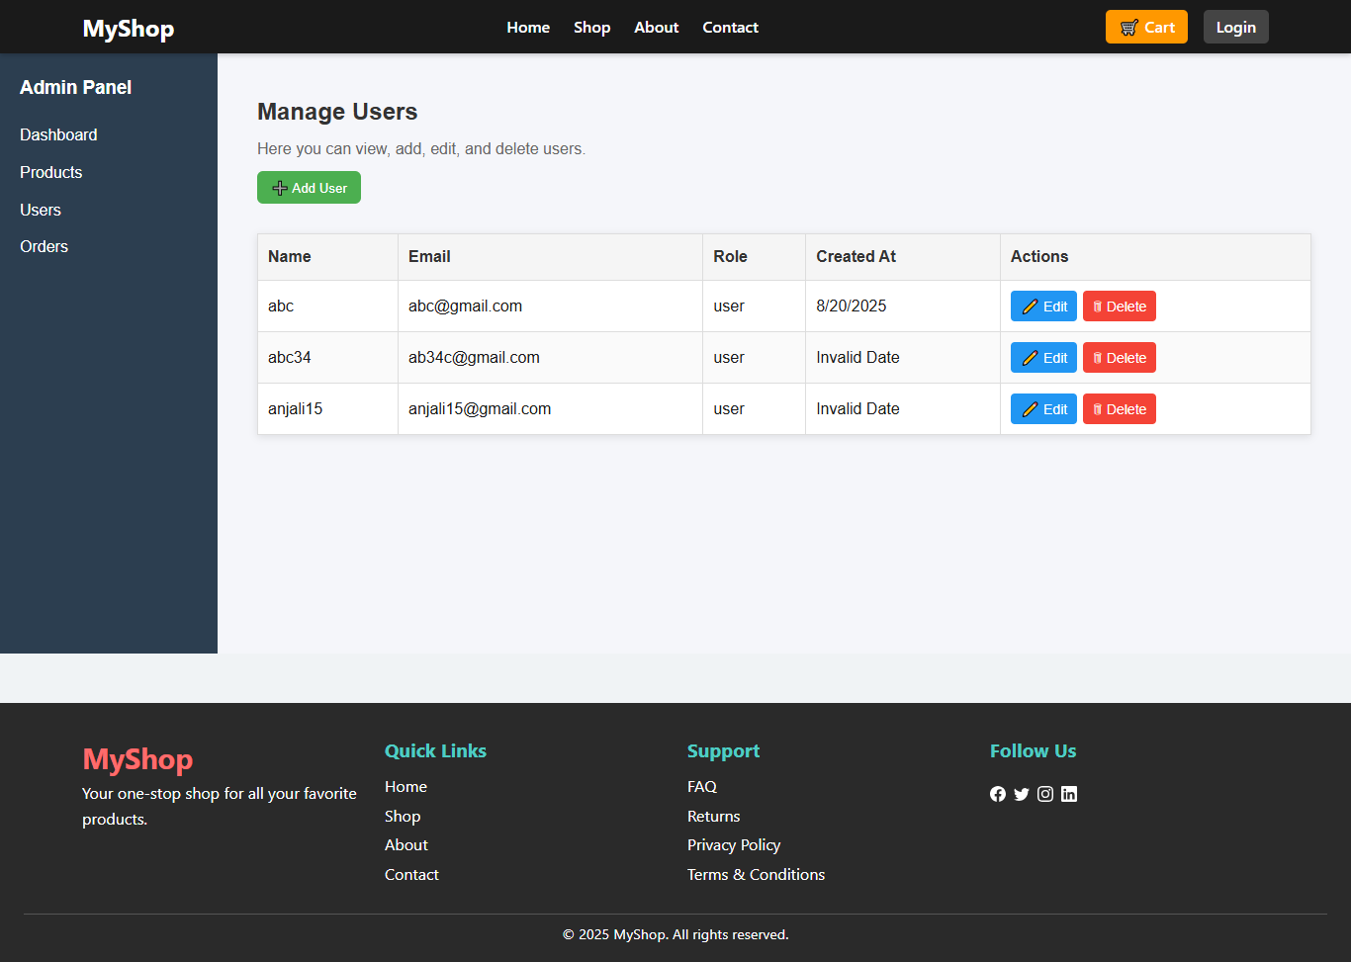
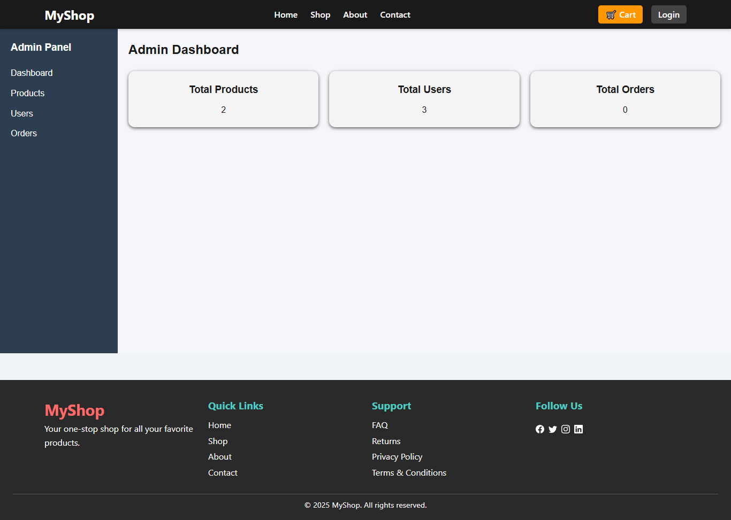
- Sales analytics, product & order management

9. Security & Validation
- JWT-based authentication
- Role-based access control (Admin/User)
- API validation and error handling
- Environment variables for sensitive data

